Skills Workshop # 2: Technical Writing & Presentation

Speaker: Dr. Margaret Kupferle, Dr. Kupferle is an Associate Professor, Department of Chemical and Environmental Engineering, College of Engineering and Applied Science, University of Cincinnati (UC)
Date: Wednesday, June 19, 2019
Time: 9:00-10:45 AM
Venue: University of Cincinnati, Baldwin Hall, room 741

Prepared by:
Pete Szyjka, Cincinnati State, Cincinnati, Ohio
RET Participant for Project #3: “Bio-Inspired Engineering”

This session was presented by Dr. Margaret Kupferle, Figure 1, Department of Chemical and Environmental Engineering at UC. This session was given by Dr. M. Kupferle, Associate Professor, Department of Chemical and Environmental Engineering, College of Engineering and Applied Science on Wednesday, June 19, 2019 from 9:00-10:45 AM at the University of Cincinnati in Baldwin, room 741 She currently teaches graduate and undergraduate courses in chemical and environmental engineering. Dr. Kupferle chairs the Environmental Engineering Program and advises the UC student chapter of Engineers Without Borders. Dr. Kupferle is the PI for the new RET grant.

Dr. Kupferle presentation was well designed to help us clearly write about engineering topics and enable a reader to quickly understand the main idea and the conclusions. She gave a series of helpful hints, Figure 2, along with interesting and enlightening group exercises designed to reinforce the learning objectives. Participant questions and group enthusiasm indicated an obviously fun and successful session.

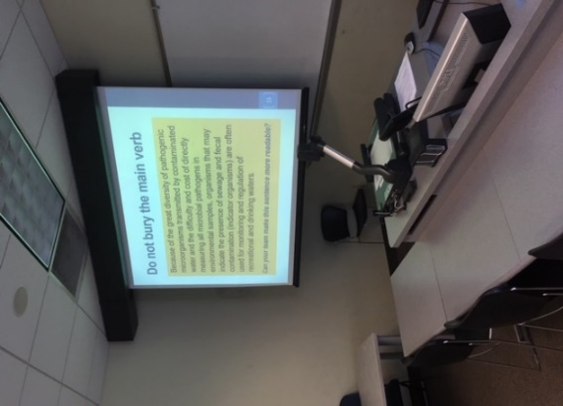
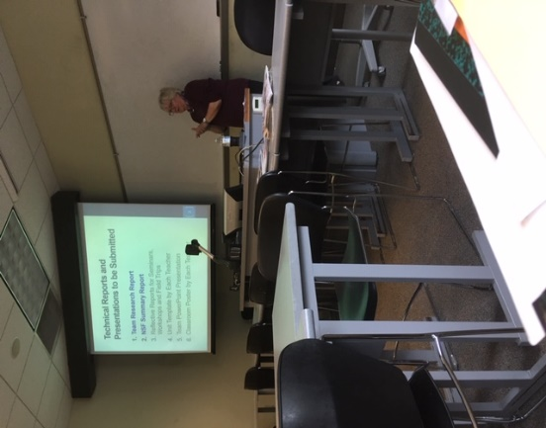
Figure 1: Dr. Kupferle Giving Advice Figure 2: Highlighting Some Topics

Dr. Kupferle had several key points to cover about technical writing. The first point included spending time doing rewrites, the second point included opening the article write-up with the message the writer wants to convey to the reader to capture their attention, and lastly Dr. Kupferle covered how to introduce the topic. The important issues were followed by recommendations on data organization, the introductory abstract and topic section placement within the paper.

The exercises that students completed, as captured in Figure 3, were the most instructive. Student teams were given published technical article segments to critique and rewrite. Following the team discussions, teachers were given the opportunity to present their rewrite proposals, clarifying the subject articles. A competitive spirit amongst teams was evidence that they were enjoying the challenges.
Specific details on journal article writing included such topics as acronyms, use of jargon, wordiness and long-winded unreadable subject matter.

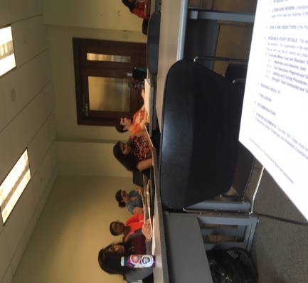

Figure 3: The Rewrite Exercises

Following each exercise, a question and answer period provided additional learning opportunity in which Dr. Kupferle displayed her impressionable enthusiasm. Additional and helpful discussions included the peer-review process, the journal article submission process and related topics. Every student was an active participant and the solid round of applause at the session conclusion was a solid indicator of instructor and class motivation.

